Semester | B.E. Semester VII– Electronics and Computer Science
Subject | DAV Laboratory
Laboratory Professor | Prof. Uma Jaishankar

Student Name | Jainam Jain
Roll Number | 23108B0084
Team Members | Jainam Jain, Vrushan Patil, Dhanush Chowke, Aditya Tambe, Vivek Jaiswal

Mini Project | Socio-Economic & Demographic Analysis of Indian Festivals
Problem Statement | India exhibits immense cultural and regional diversity, with hundreds of festivals celebrated across states, communities and calendar months. Unstructured information leads to biased representations and missing comparative insight. The project must (1) collect an authentic multi-faith festival dataset with zero synthetic records and exact source URLs, (2) build and evaluate ML models, (3) perform rigorous statistical testing and EDA, (4) publish a public data-visualisation blog with 40+ external interactions, and (5) produce a synthesis video.
Resources | Software: Python 3.12, Windows 11, ffmpeg, Windows SAPI (System.Speech) for narration, Microsoft Word (PDF export), MS Edge + Playwright.  Libraries: pandas, numpy, scipy, statsmodels, scikit-learn, joblib, matplotlib, plotly, requests, BeautifulSoup, xlrd, markdown.  Data sources (all real, cited per record): Reserve Bank of India holiday matrix 2024-26 (rbi.org.in); Census of India 2011 Table C-01 (censusindia.gov.in); Wikipedia infoboxes via MediaWiki API + Govt. portals (utsav.gov.in, soreng.nic.in, dtahills.mn.gov.in, megtourism.gov.in); CAIT (cait.in) and verified news for spending; NRF, gov.cn, GASTAT, muenchen.de for global analogues; DataMeet state boundaries (CC BY 2.5 IN).
Deliverables | Task 1 - data/raw/*.csv|json (raw with source columns), data/processed/*.csv (clean), data/data_dictionary.md|csv  Task 2 - code/06_ml_models.py, model weights outputs/models/*.joblib, metrics outputs/ml/*.csv, ml_summary.json  Task 3 - outputs/stats/statistical_summary.md + T1-T10 validation tables, figures F01-F10  Task 4 - blog/blog_post.md|html, blog/images, blog/interactive/*.html, blog/engagement (log template, audit report)  Task 5 - video/Indian_Festivals_Project_Report.mp4 (1080p, narrated), video/narration_script.md, this report
Approach | 1. Scrape the RBI holiday matrix for every office/month/year (2,031 office-date rows), save raw HTML + CSV with source URL per row.  2. Build a 99-festival regex catalog; resolve each RBI label into festivals; split shared-date closures with attribution_weight = 1/k; flag festivals whose reach is not identifiable.  3. Source-ground each festival's tradition from its Wikipedia infobox ('Observed by') or an official Govt. page.  4. Download Census 2011 C-01, map 34 RBI offices to 29 states/UTs, build festival-, observation- and state-level tables.  5. Collect 78 economic/footfall figures; open every page to confirm the figure (snippet-only figures were excluded).  6. EDA & hypothesis tests (chi-square, permutation, Spearman, Kruskal-Wallis, Mann-Whitney, OLS).  7. ML: K-Means/Ward clustering of states, Random Forest vs Logistic tradition classifier, log-linear trade regression with LOO and temporal hold-out.  8. Blog + interactive Plotly charts, engagement audit tooling; 9. narrated video; 10. report.
Code | 01_scrape_rbi_holidays.py 02_verify_wikipedia.py 03_economic_footfall_records.py  04_build_clean_dataset.py 05_eda_statistics.py 06_ml_models.py  07_data_dictionary.py 08_interactive_charts.py 09_blog_and_engagement.py  10_make_video.py 11_build_report.py festival_catalog.py viz_style.py  Excerpt - fractional attribution of shared-date holidays (04_build_clean_dataset.py):  obs["n_items_on_date"] = obs.groupby(["date","rbi_regional_office"])["festival"]  .transform("size") + obs["n_civic_items"]  obs["attribution_weight"] = 1 / obs["n_items_on_date"]  obs["attribution"] = np.where(obs["n_items_on_date"] == 1, "unique", "shared_date")
Task 1: Dataset | 2,705 festival-holiday observations | 99 festivals | 34 RBI offices | 29 states/UTs | 2024-2026 | 78 verified economic/footfall records | Census 2011 demography. Zero synthetic records.  Limitations: RBI publishes one combined label per date, so co-listed festivals share the day (39 of 99 festivals never appear alone -> reach flagged not identifiable); bank holidays measure official recognition, not participation; trade figures are industry estimates.
  tradition | festivals | holiday-days/office/yr | % of festival holidays | % moving-date
  Hindu | 45 | 7.22 | 46.5 | 68.89
  Tribal/Indigenous | 22 | 1.13 | 7.3 | 63.64
  Muslim | 7 | 2.69 | 17.3 | 100.0
  Christian | 7 | 2.1 | 13.5 | 14.29
  Buddhist | 6 | 0.63 | 4.0 | 83.33
  Sikh | 5 | 0.43 | 2.8 | 60.0
  Cultural (multi-faith) | 4 | 0.51 | 3.3 | 25.0
  Jain | 2 | 0.37 | 2.4 | 100.0
  Parsi | 1 | 0.44 | 2.9 | 0.0
Task 3: Statistics | H1: holidays cluster by month (chi2 = 551, p < 0.001; peaks Mar, Oct, Apr). H2: season independent of tradition (perm. p = 0.58). H3: holiday share correlates with population share for all six faiths (rho 0.42-0.71, p < 0.05). H4-H7 not significant. H9: festive trade grows 34.0%/yr (95% CI 27.2 to 41.1).
  variable | n | mean | median | std | skewness
  festival_expected_states_per_year | 99.0 | 4.11 | 1.27 | 6.32 | 2.44
  festival_mean_holiday_days (duration) | 99.0 | 1.03 | 1.0 | 0.09 | 4.44
  festival_date_drift_days (moving festivals) | 64.0 | 23.19 | 19.0 | 43.7 | 7.65
  state_festival_holidays_per_year (frequency) | 29.0 | 15.39 | 15.32 | 2.49 | 0.27
  state_holiday_diversity_shannon | 29.0 | 1.54 | 1.52 | 0.14 | 0.46
  state_distinct_festivals_2024_26 | 29.0 | 34.97 | 35.0 | 5.68 | -0.52
  festive_trade_INR_crore (spending) | 18.0 | 118166.67 | 37500.0 | 173144.7 | 1.77
  id | test | statistic | p_value | result
  H1 | Chi-square goodness-of-fit (12 months, weighted | 551.155 | < 0.001 | Reject H0
  H2 | Chi-square test of independence (+5,000-permutat | 7.719 | 0.578 | Fail to reject H0
  H3-Hindu | Spearman rank correlation (n=29 states/UTs) | 0.575 | 0.001 | Reject H0
  H3-Muslim | Spearman rank correlation (n=29 states/UTs) | 0.422 | 0.022 | Reject H0
  H3-Christian | Spearman rank correlation (n=29 states/UTs) | 0.532 | 0.003 | Reject H0
  H3-Sikh | Spearman rank correlation (n=29 states/UTs) | 0.536 | 0.003 | Reject H0
  H3-Buddhist | Spearman rank correlation (n=29 states/UTs) | 0.709 | < 0.001 | Reject H0
  H3-Jain | Spearman rank correlation (n=29 states/UTs) | 0.639 | < 0.001 | Reject H0
  H4 | Kruskal-Wallis H (identifiable-reach festivals) | 7.251 | 0.064 | Fail to reject H0
  H5 | Mann-Whitney U | 885.500 | 0.270 | Fail to reject H0
  H6-hol_days | Kruskal-Wallis H | 3.788 | 0.580 | Fail to reject H0
  H6-holiday_ | Kruskal-Wallis H | 4.587 | 0.468 | Fail to reject H0
  H7 | Spearman rank correlation | 0.248 | 0.194 | Fail to reject H0
  H8 | Mann-Whitney U on log trade (national CAIT-type | 52.000 | 0.109 | Fail to reject H0
  H9 | OLS log(trade) ~ year + festival fixed effects | 12.469 | < 0.001 | Reject H0
Task 2: Machine Learning | A. Clustering states (K-Means vs Ward)  Features: Hindu/Muslim/Christian/Tribal shares of festival holidays (chosen by a documented feature-set experiment). k = 4 (silhouette 0.413); bootstrap ARI 0.61 +/- 0.28; ARI vs region 0.03.  C1: above-avg Christian holiday share: Arunachal Pradesh, Goa, Mizoram, Nagaland; C2: above-avg Hindu holiday share: Andhra Pradesh, Assam, Bihar, Gujarat, Himachal Pradesh, Jharkhand, Karnataka, Madhya Pradesh, Maharashtra, Odisha, Punjab-Haryana-Chandigarh, Rajasthan, Sikkim, Tamil Nadu, Telangana, Uttar Pradesh, Uttarakhand, West Bengal; C3: above-avg Muslim holiday share: Chhattisgarh, Delhi, Jammu & Kashmir, Kerala; C4: above-avg Tribal Indigenous holiday share: Manipur, Meghalaya, Tripura  B. Tradition classifier (5-fold x 20 repeated stratified CV)  C. Festive-trade regression (log-linear, festival fixed effects)  n = 15; in-sample R2 (log) 0.993; LOO RMSE 0.281 log units; LOO MAPE 20.2%; growth 35.5%/yr; hold-out 2026 MAPE 13.1% (Holi 2.9%, Raksha Bandhan 23.2%).
  model | accuracy_mean | macro_precision_mean | macro_recall_mean | macro_f1_mean | macro_f1_sd
  Majority baseline | 0.455 | 0.114 | 0.25 | 0.156 | 0.002
  Logistic Regression | 0.434 | 0.42 | 0.424 | 0.4 | 0.106
  Random Forest | 0.464 | 0.419 | 0.424 | 0.404 | 0.105
Task 4: Blog & Engagement | Article 'What India's Bank-Holiday Calendar Reveals About How the Country Celebrates' (~1,700 words, 9 figures, 8 footnoted sources, secular framing) in blog/blog_post.md and a paste-ready blog_post.html; 4 interactive Plotly charts (hover tooltips) in blog/interactive/.  Publication status: https://medium.com/@i.jainamjain/what-indias-bank-holiday-calendar-reveals-about-how-the-country-celebrates-97c99917b2d3. External interactions logged: 0 / 40 target; comments answered: 0. The audit (09_blog_and_engagement.py) counts only people outside VIT and requires a screenshot per row. Publishing and community engagement must be done by the author; no engagement is simulated.
Task 5: Video | video/Indian_Festivals_Project_Report.mp4 - 1920x1080, H.264/AAC, 11 narrated slides (~5.4 min): motivation & source integrity, statistics, ML architecture & performance, economics, blog & reception, takeaways. The reception slide reads engagement_metrics.json; re-run 10_make_video.py after publishing to produce the final cut.
Output Visuals | 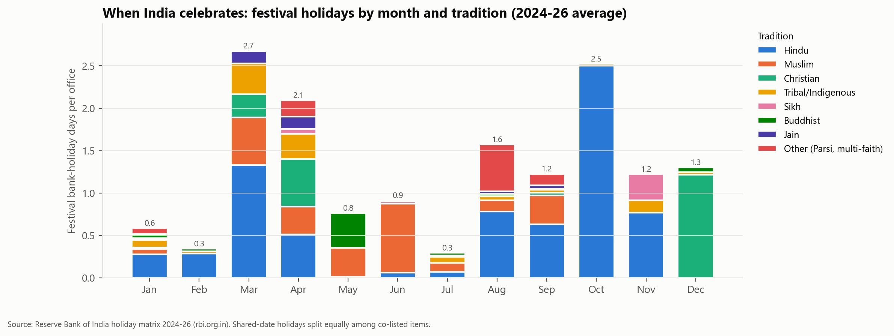  Fig 1. Festival bank-holiday days by month and tradition (RBI 2024-26).  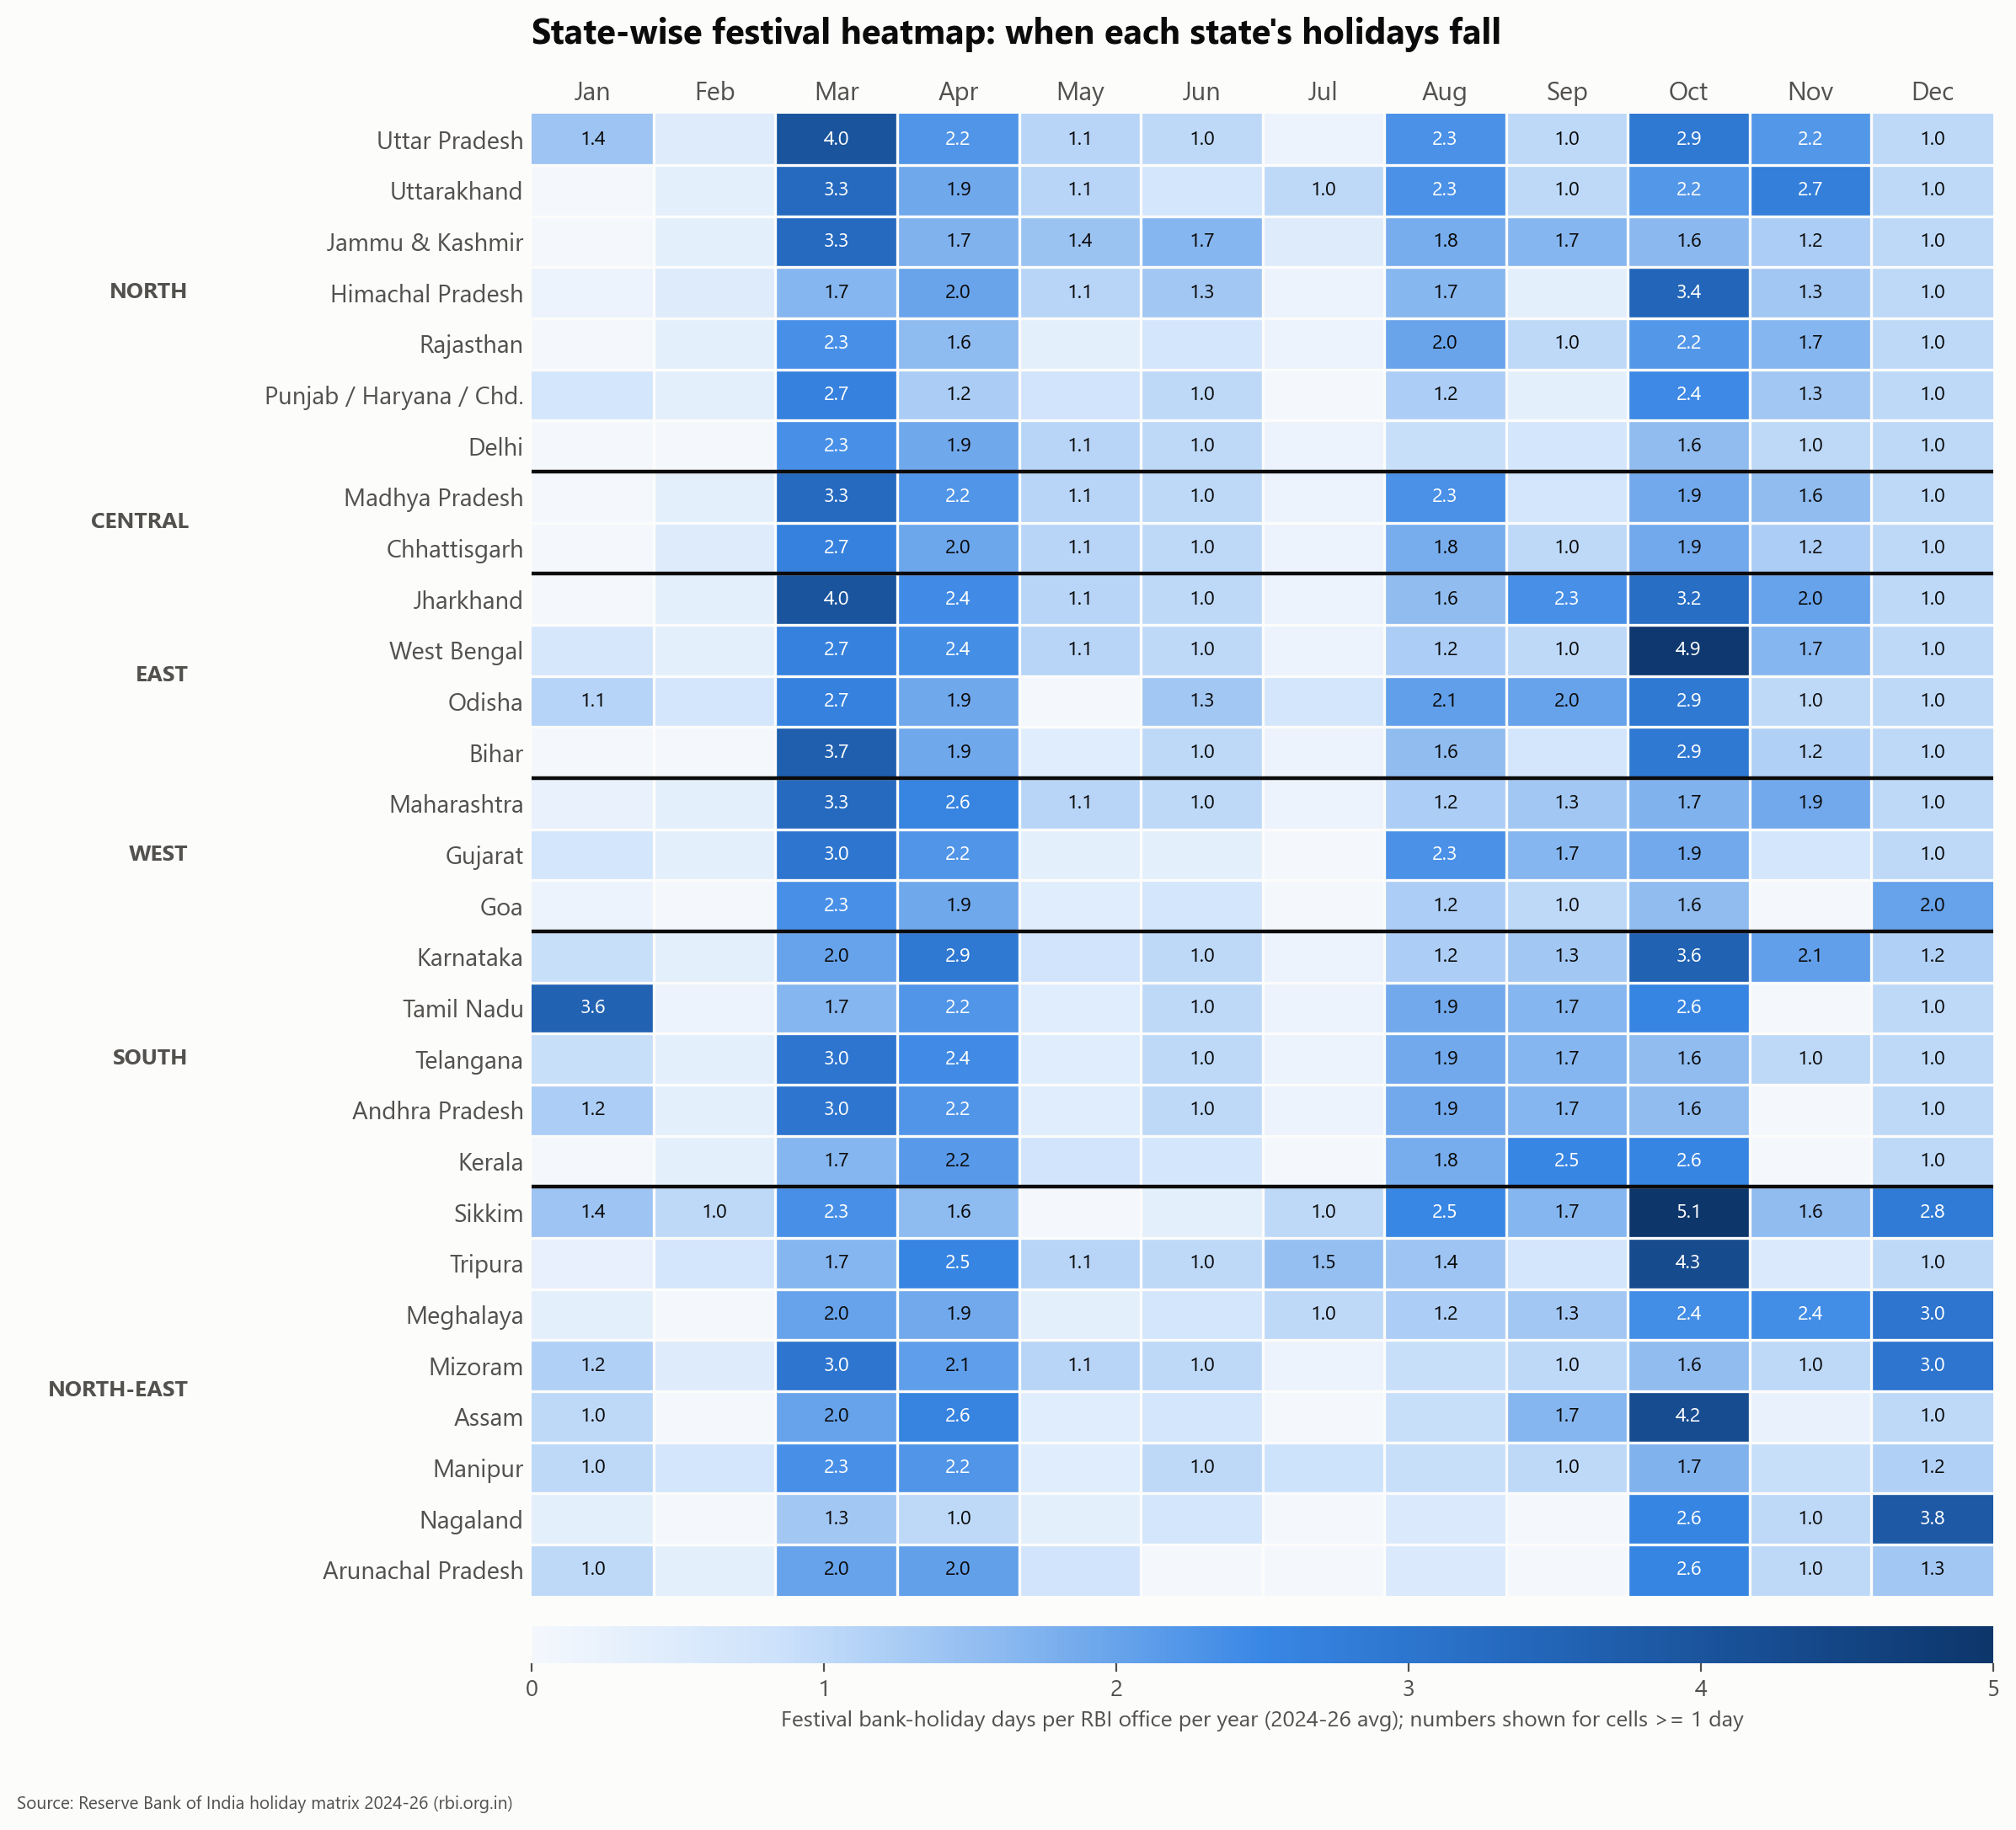  Fig 2. State x month heatmap.  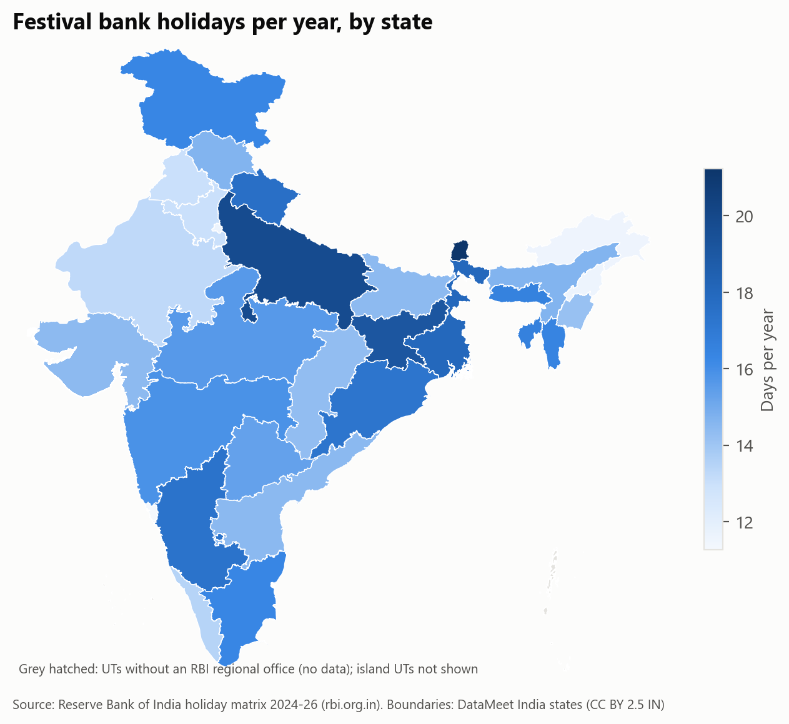  Fig 3. Festival holidays per year by state.  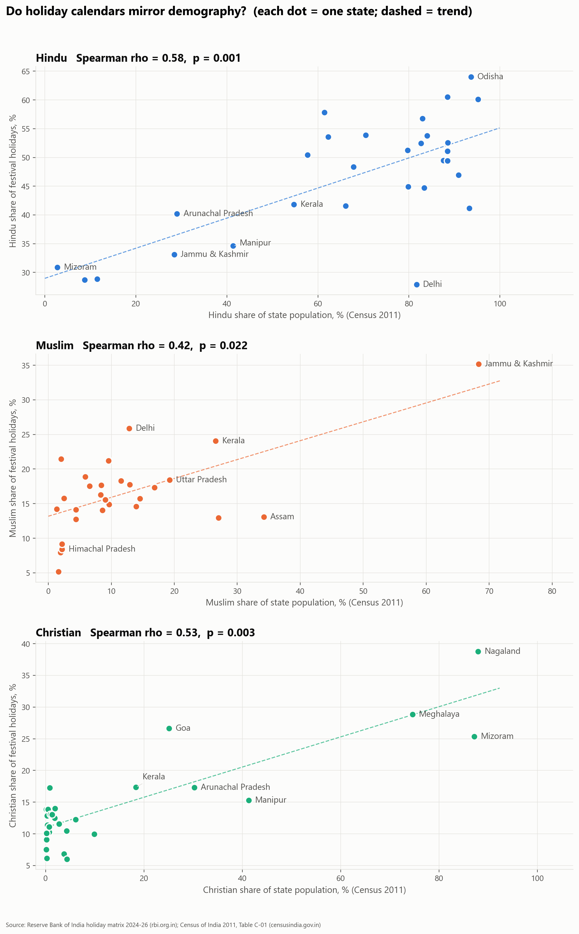  Fig 4. Holiday share vs Census population share.  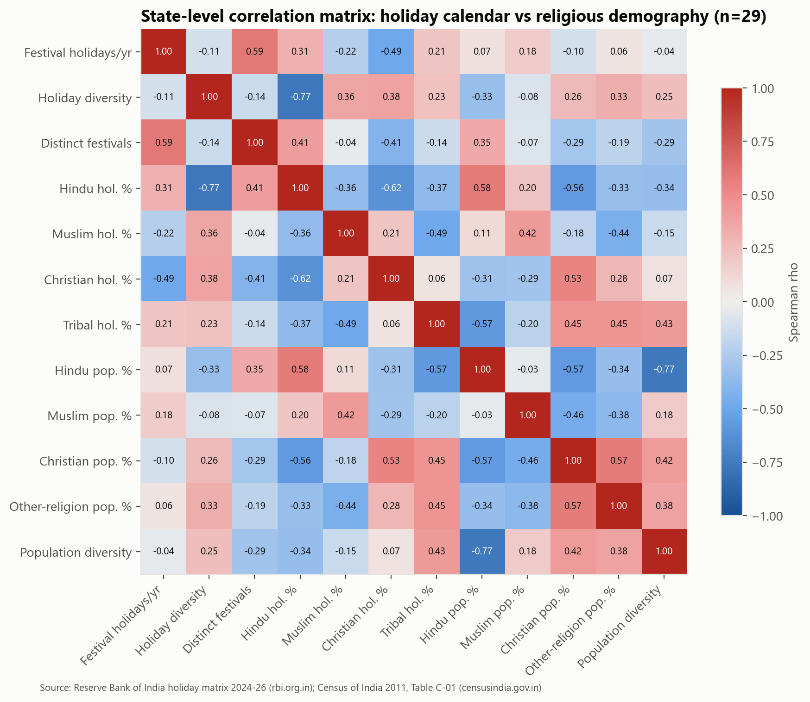  Fig 5. State-level Spearman correlation matrix.  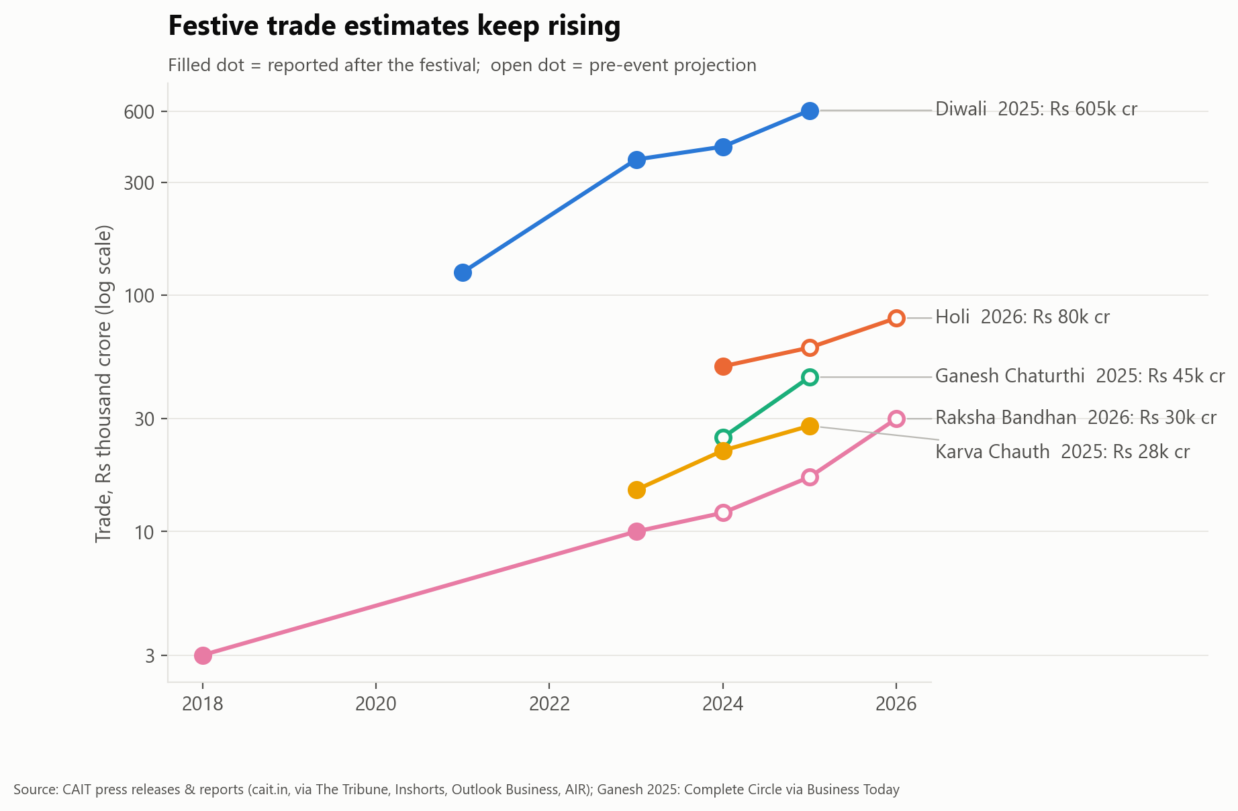  Fig 6. Festive trade estimates (CAIT).  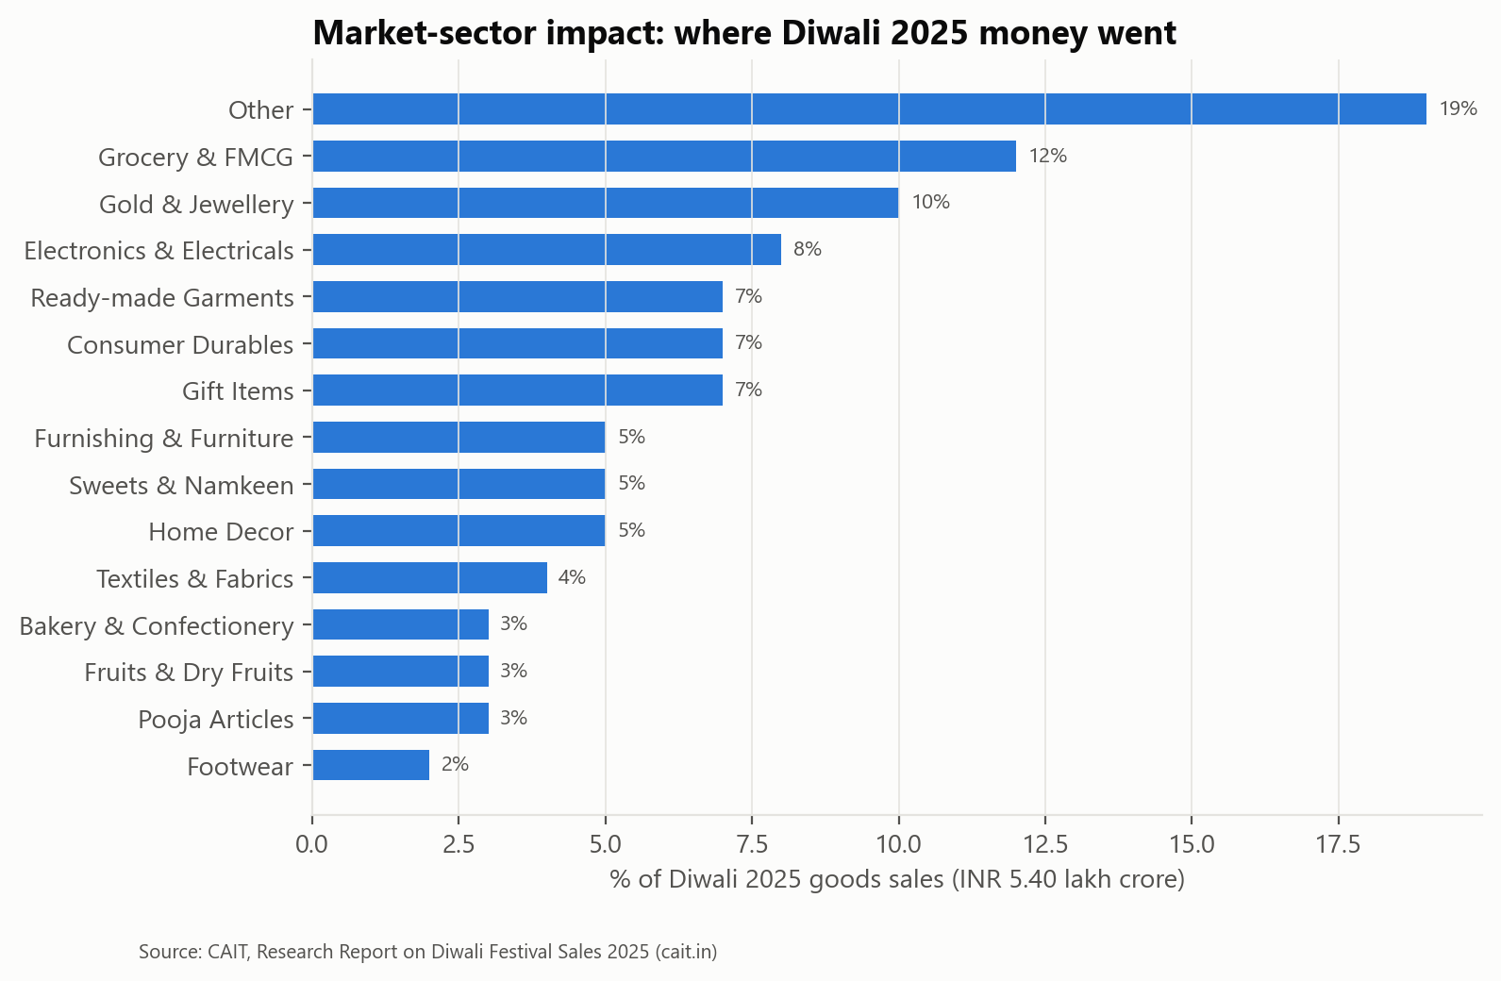  Fig 7. Diwali 2025 sector split.  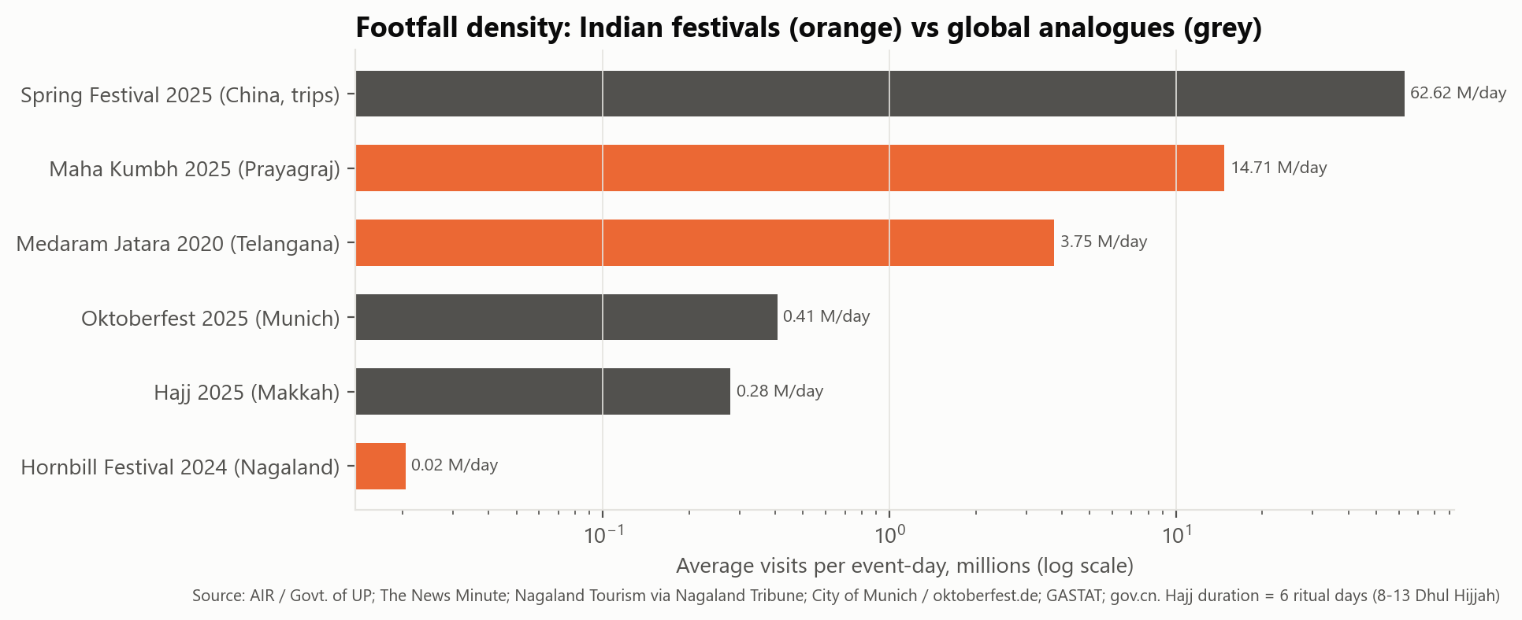  Fig 8. Footfall density vs global analogues.  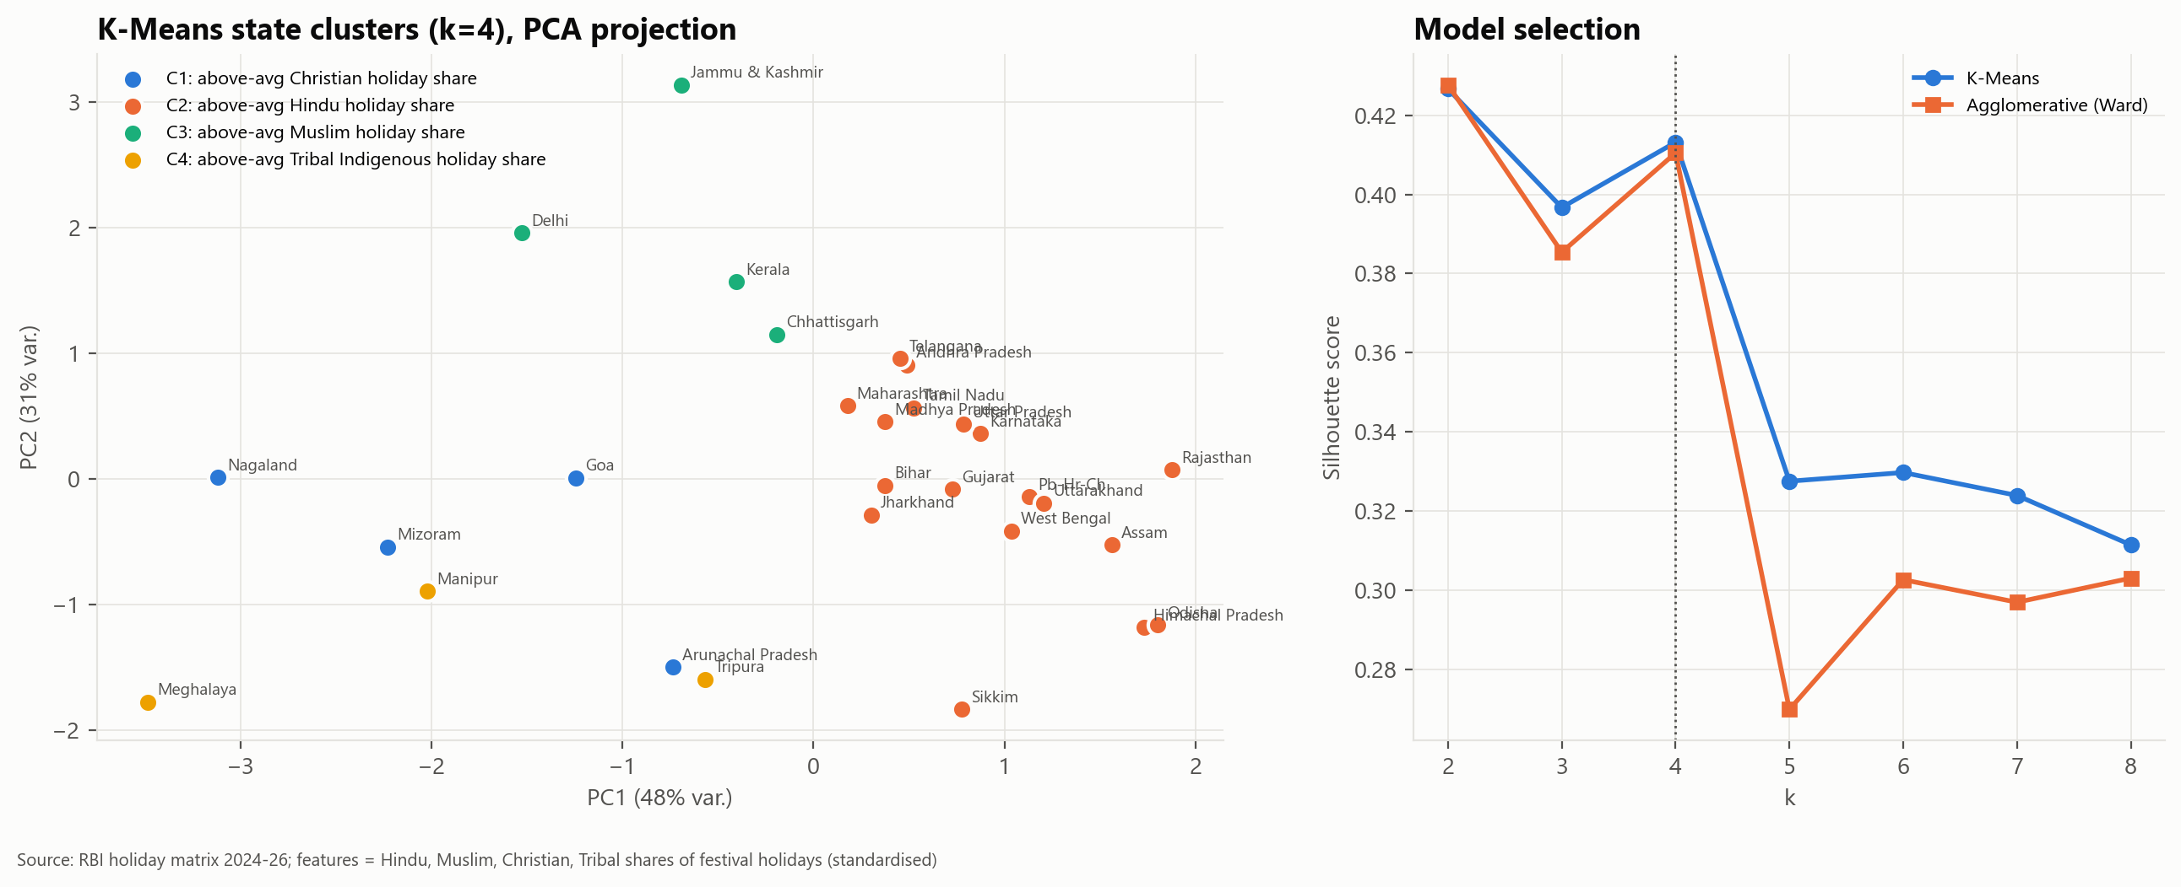  Fig 9. K-Means state clusters (PCA) and model selection.  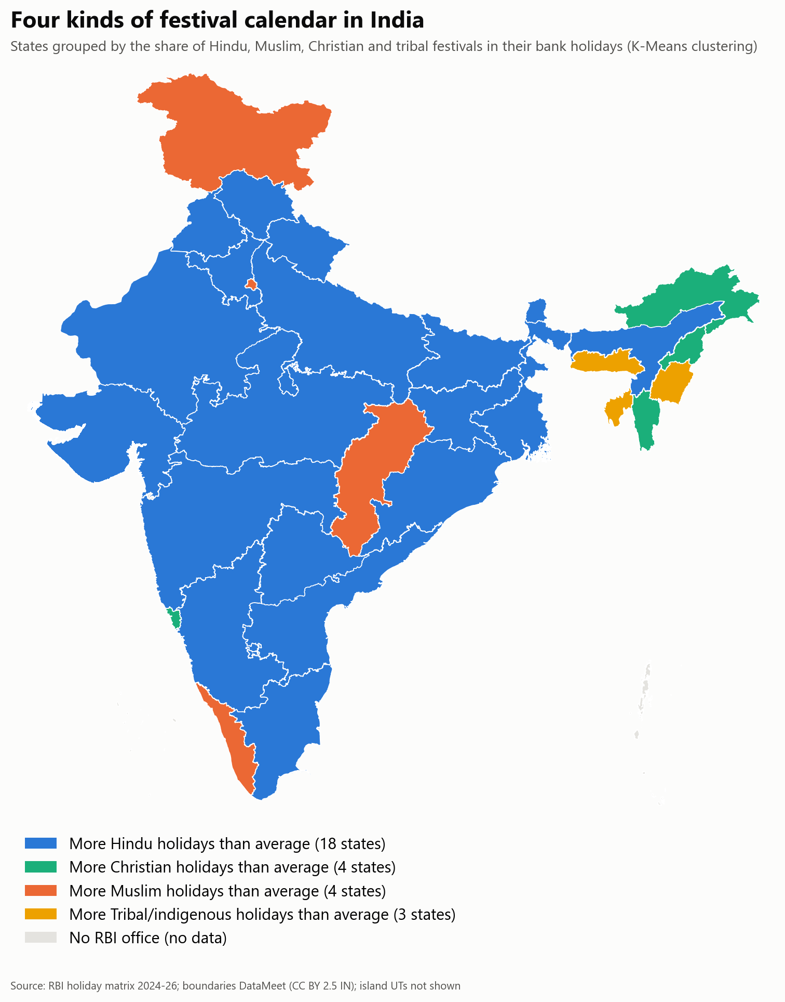  Fig 9b. State clusters on the map.  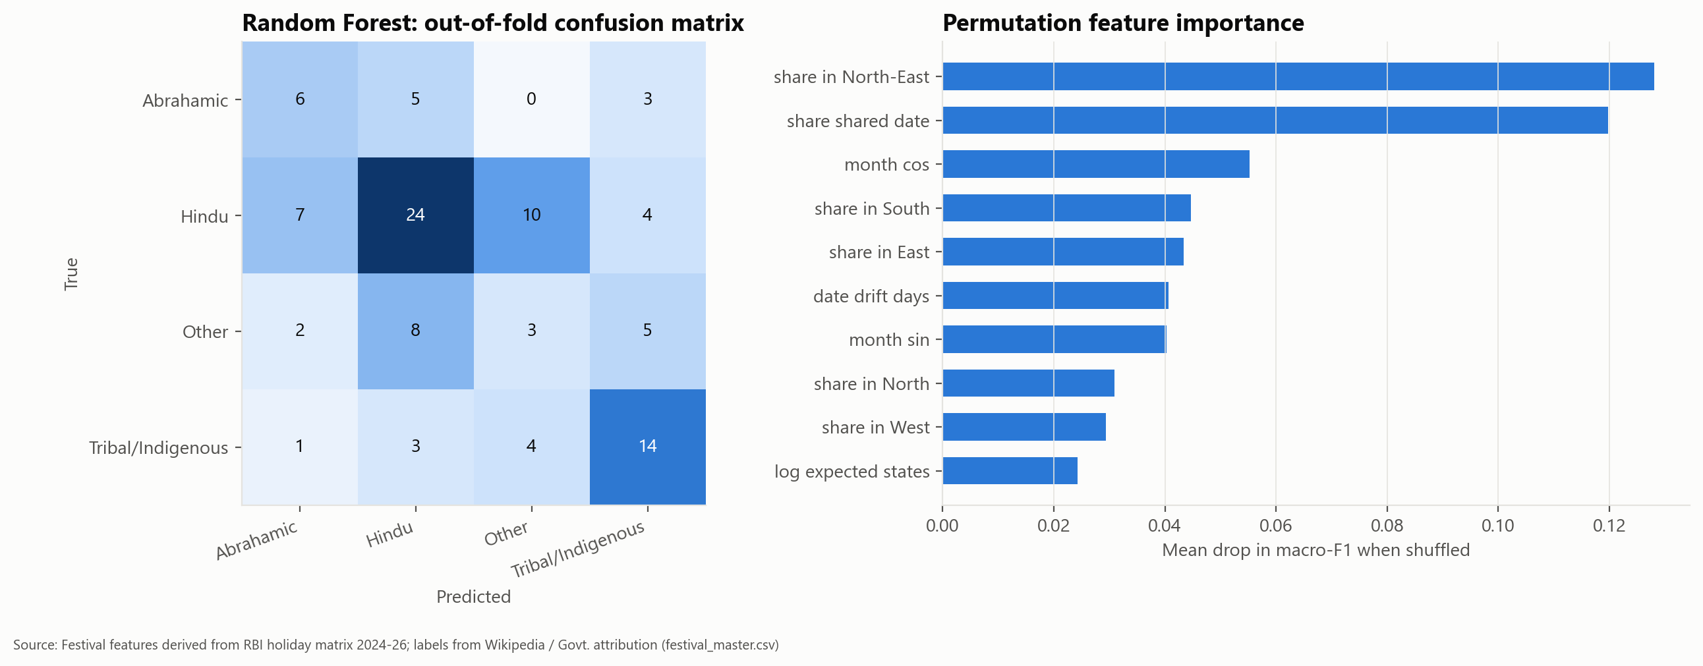  Fig 10. Classifier confusion matrix and permutation importance.  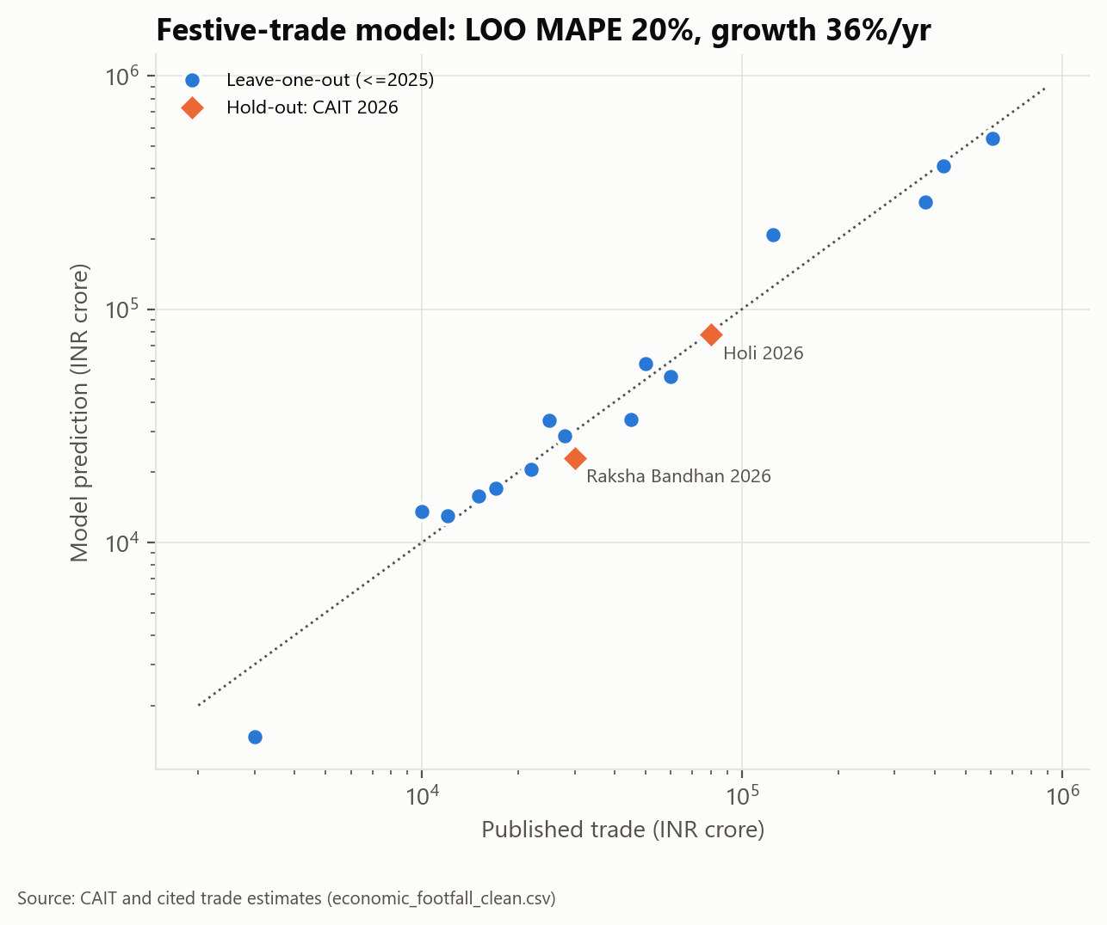  Fig 11. Trade model: LOO and 2026 hold-out predictions.
Insights | 1. Festival holidays peak in March (2.7 days/office), October (2.5) and April (2.1); February and July are quietest.  2. Every faith's holiday share rises with its population share (Spearman 0.42-0.71), yet the calendar is more plural than the population: Hindu festivals are ~46% of festival holidays vs 79.8% of population, because Christmas, Good Friday, both Eids, Buddha Purnima, Mahavir Jayanti and Guru Nanak Jayanti are gazetted almost nationwide.  3. Sikkim (21.2), Uttar Pradesh (19.8) and Jharkhand (19.1) have the most festival holidays; Goa (11.3) the fewest. Regions do not differ significantly.  4. States cluster by calendar culture, not geography (ARI vs region 0.03).  5. A festival's date and footprint only weakly reveal its faith (macro-F1 0.40): nationwide festivals of all faiths look alike.  6. Reported festive trade grows ~34%/yr (Diwali: Rs 1.25 lakh cr in 2021 -> Rs 6.05 lakh cr in 2025), but national spending estimates exist mainly for Hindu festivals - a measurement blind spot.
Conclusion | A fully source-grounded, multi-faith festival dataset was built from official RBI and Census data plus 78 verified economic figures, analysed with hypothesis tests and three ML models, and communicated through a footnoted blog, interactive charts and a narrated video. Remaining author actions: publish the article, collect 40+ genuine external interactions, fill the engagement log, and re-run the audit and video scripts.
References | [1] RBI, Holidays under NI Act - https://www.rbi.org.in/Scripts/HolidayMatrixDisplay.aspx  [2] Census of India 2011, C-01 - https://censusindia.gov.in/nada/index.php/catalog/11361  [3] CAIT Diwali 2025 report - https://cait.in (10 Nov 2025); other economic sources listed per record in data/raw/economic_footfall_raw.csv  [4] All India Radio, Maha Kumbh concludes - https://www.newsonair.gov.in/maha-kumbh-mela-2025-concludes-in-prayagraj-on-maha-shivratri  [5] NRF (16 Jan 2025); gov.cn (5 Feb 2025); GASTAT (5 Jun 2025); muenchen.de - global analogues  [6] DataMeet India state boundaries (CC BY 2.5 IN) - github.com/datameet/maps

